A reminder that parents are always welcome in the school whether to assist with school programs or to speak with teachers. If you would like to know how to best assist your child’s education just contact the teacher of your choice or the school office on 63741622.

This Week

Swim School starts this week

Dental Van visit Tuesday & Wednesday

Ten Dollar Circus @ Gulgong Markets Saturday morning Coronation Park 9.00-11.30



**Coming Up**

Xmas Disco Thursday December 5

Year 6 Farewell December 12

Presentation Day December 17

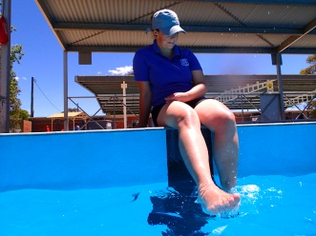

In This Issue

|  |  |
| --- | --- |
| Principal’s Message | 1/2 |
| School News Update | 2/3 |
| P&C News | 2 |
| Virtues | 3 |
| Community Notices | 3 |
| Sponsors | 4 |



**Principal’s Message**

**Congratulations**

**To:**  All the Year 5 students who nominated for prefect for next year. The speeches were outstanding. Any of the candidates would be worthy prefects and captains.

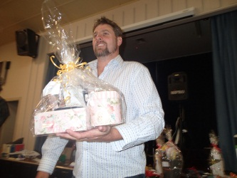**Thank You**

**To:** Staff and parents who organised the very successful Trivia Night.

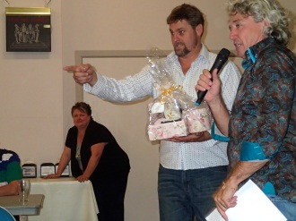**To:** Nick Wake and Naomi Haney from CRT Gulgong for their work on the Auction at our Trivia Night.

**To:** Gulgong RSL for hospitality in the venue for our Trivia Night.

**To:** The local businesses who supported our Trivia Night.

***Gulgong Butchery, Gulgong Dispensary,***

***Shell Service Station, BP Service Station, IGA, Pearsons’ Jewellers, Gulgong Newsagency,***

***Annette Everingham, Stack’s Down Under,***

***Prince of Wales Hotel, Commercial Hotel, Centennial Hotel, Akaih Massage & Gifts, Peta’s Kuts & Kurls, Butcher Shop Café, CRT, McDonalds Bakery, Gulgong Timber & Hardware.***







**Prefect’s Elections**

Congratulations to the 17 students who gave their speeches on Friday. All those students deserve accolade for a job well done in very nerve-wracking circumstances.

All of the students who stood for election would be very worthy prefects in 2014 and all will still have a leadership role to play as mentors for younger students.

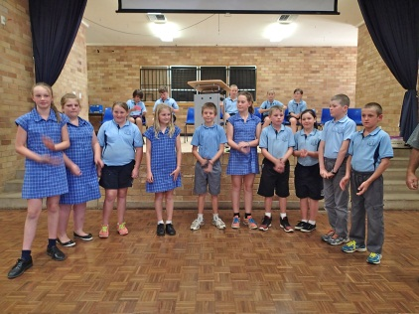The prefects elected in alphabetical order are:

*Zac Barrass, Joshua Campbell, Chelsea Everingham, Declan Kirk, Aydin Patrick, Holly Potter Jayden Pepper, Hollie Smith, Isabelle Towerton, Brittnee Woods*

The two captains will be announced on Presentation Day when all the prefects will be given their badges of office.

**Ten Dollar Circus**

The Ten Dollar Circus has been booked for a variety of jobs coming up. I appreciate the support parents give to this program in our school and say thank you for getting your children to our gigs.

Coming up:

* *Saturday November 23 – Coronation Park Markets 9.00-11.30am*
* *Saturday December 21 – Gulgong Christmas Party in ANZAC Park*
* 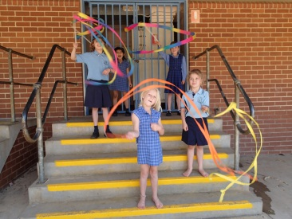*Saturday Sunday December 28-29 Folk Festival*

Notes with specific details about these events have been sent home. Many thanks in anticipation of your support in getting your children along to these events, especially on the weekends.

**Presentation Day**

This year’s Presentation Day will be held in the high school gym and will be one event, K-6. Estimated duration is around 90 -100 minutes and we will commence around 11.00am.

**Attendance**

We are seeking a 100% attendance record from all students this term. Please help to give your child every chance for educational success by ensuring that they attend every day possible.

If your child is sick or you have a compelling family reason for them to miss school, please provide an explanatory note within three days.

**Enrolments for 2014**

Enrolment forms for Kindergarten 2014 are now available at the school office.

Enrolment with our school for 2014 in any grade from Kindergarten to Year 6 can be made at the school office at any time. Please contact the school office on 63741622 if more information about our school is required.

If you know of anyone thinking about enrolling at our school or leaving our school please encourage them to contact us ASAP so our planning can be more effective.

**P&C News**

P&C meets on the first Wednesday each month at 5.30pm in the Staffroom. The next meeting is Wednesday December 4th Christmas Party – venue TBA.

The minutes of meetings are available for download from the school website.

All parents are welcome to attend P&C meetings and to contact the committee on matters to do with the school.

**Canteen**

The Canteen operates on a volunteer basis under Manager Julie Shearer. More volunteers are always sought. If you can spare any time to help in the canteen just contact Julie on 63 741060. You can also just walk in and make yourself known at any time.

**School Web Site**

The Gulgong Public School Web Site is at the following address:

[www.gulgong-p.schools.nsw.edu.au](http://www.gulgong-p.schools.nsw.edu.au)

Please feel free to visit the site for information and photos of activities going on in our school for and with your children.

**Alan Walker**

Principal



**SCHOOL NEWS**

**j0231971Christmas in the Churches**

On Thursday 12th December 2013, students from K-6 will participate in their final Scripture event for the year with interdenominational Christmas services held at the various churches in Gulgong (Catholic, Anglican, Presbyterian).

Students whose parents/carers have listed the above denominations will attend the Christmas service at that Church. Please note students who have nominated Uniting Church will attend the Presbyterian Church.

Those students whose parents have not listed a preferred denomination and who attend Scripture regularly will be divided between the three Churches holding services.

The Christmas services are to celebrate the Christmas season and will not involve other religious doctrine. If you have concerns where your student will attend the Christmas service please contact the school.

Non Scripture students will remain at school with a supervising teacher.

**LIBRARY CORNER**

**There will be NO BORROWING of books after this week**.

**STARS of the WEEK**

***KG-*Joseph –**A great effort with all tasks

**KB – Daine –** Always doing his neatest work

***1/2H-* Travis –** Applying himself to tasks all week

**1/2W- Denver –** Always ready to learn

**1/2KH – Tommy –** Engaged in all tasks



**THIS WEEK’S VIRTUE:**

Peacefulness

**What is Peacefulness?**

Peacefulness is an inner sense of calm. It comes especially in quiet moments of reflection or gratitude. It is getting very quiet and looking at things so you can understand them. Peacefulness is a way of approaching conflict with others so that no one is made wrong. It is being fair to others and yourself. Peace is giving up the love of power for the power of love. With peacefulness, everyone wins.

**Why Practice It?**

Practicing peacefulness helps to create a calm mind free from worry. When you are peaceful, you respect others and their differences. People around you feel calm and safe. Without peace, no one is safe. People get hurt. Fighting doesn’t solve problems, and no one ever really wins a war. With peacefulness, any problem can be solved. Peace in the world begins with peace in your heart.

**How Do You Practice It?**

To find inner peace, become very still and think peaceful thoughts. Observe and think about your feelings, like anger, instead of acting with anger. To be peacemaker, use peaceful language instead of name-calling, yelling or gossiping. Avoid aggressive or violent actions. Talk things out and listen to the other person too. Then look for a peaceful solution. Peacemakers find there are lots of creative ways to solve any problem. Violence never solves anything.

**Affirmation**

*“I am peaceful. I use peaceful language and find peaceful solutions to any problem that arises. I find my inner peace and let it carry me gently through the day.”*

**COMMUNITY EVENTS**

**Gulgong Show 2014**

Two new attractions for the Gulgong Show, 15th February, 2015.



**SPONSORS**



**Gulgong Timber and Hardware**

For all your

Building, Plumbing

Farming and Gas supplies

Ph: (02) 6374 2199



**MUSIC COACHING**

**Beginner to Intermediate**

**Trumpet – All Saxaphones – Trombone – Clarinet**



**Competitive Rates**

**Phone Grant Stahl 6374 1138**

**For information and appointments**



***WANNA JUMP JUMPING CASTLES***

**Hire a Jumping Castle for your next event.**

Business Promotions **Ph: 0407 745 100**

RHONDA WATT

A.MUS.A L.MUS.A LTCL

Tuition in piano, flute, clarinet,

Theory& musicianship

Professional pianist, available for weddings,

Etc & accompanying for Eisteddfods,

Exams, etc

66 Rouse St, Gulgong 2852

Phone: (02)6374 1344



SHAHN’S FAMILY DAY CARE

6 WHITE ST, GULGONG

PHONE: 0429 600 619

FOR MORE INFORMATION

**STUDIO 9**

**Beauty Therapist**

*Facials, Waxing, Massage, Manicures*

*Body Wraps, Tinting, Pedicures*

*(02) 6374 2445*

*Tallawang St, Gulgong, NSW, 2852*

KELLY’S

KELLY’S

Studio 9